1. Count the number of identities(Aadhaar) generated in each state?
--- select state,count(aadhar generated) from aadhar where aadhar generated=1 group by state;

This output is Count of aadhad generated by each state.
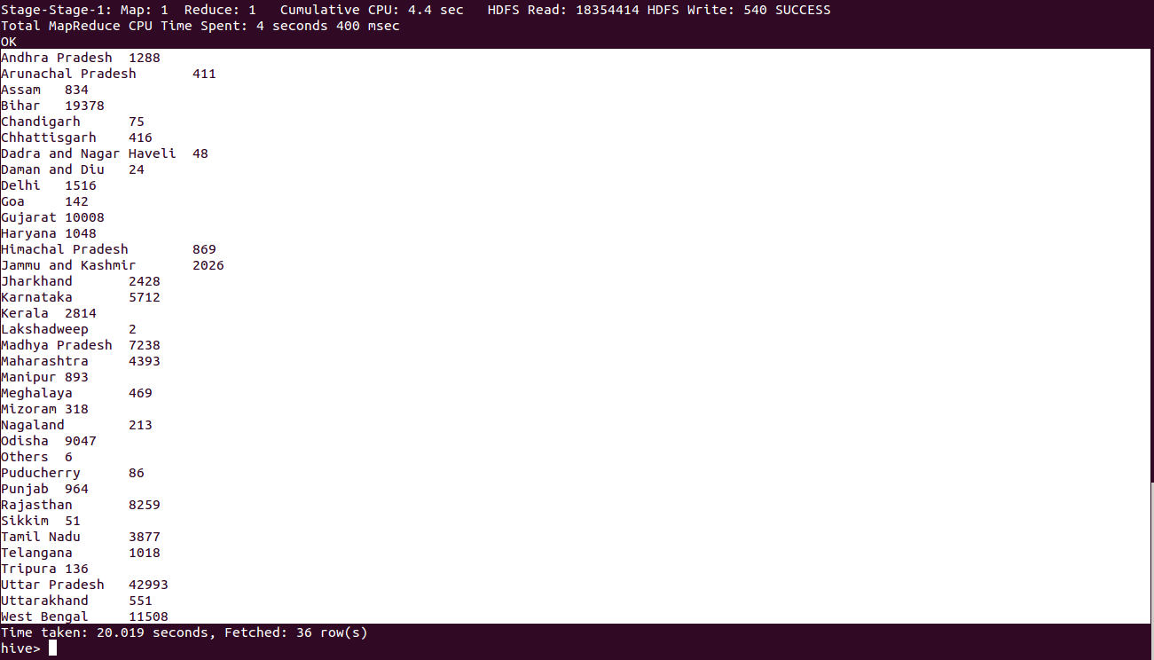

2. Count the number of identities generated by each Enrolment Agency?
---select enrolment agency,count(aadhar generated) from aadhar where aadhar generated=1 group by enrloment agency;

This output is Count of the aadhar cards generated by each Agency.

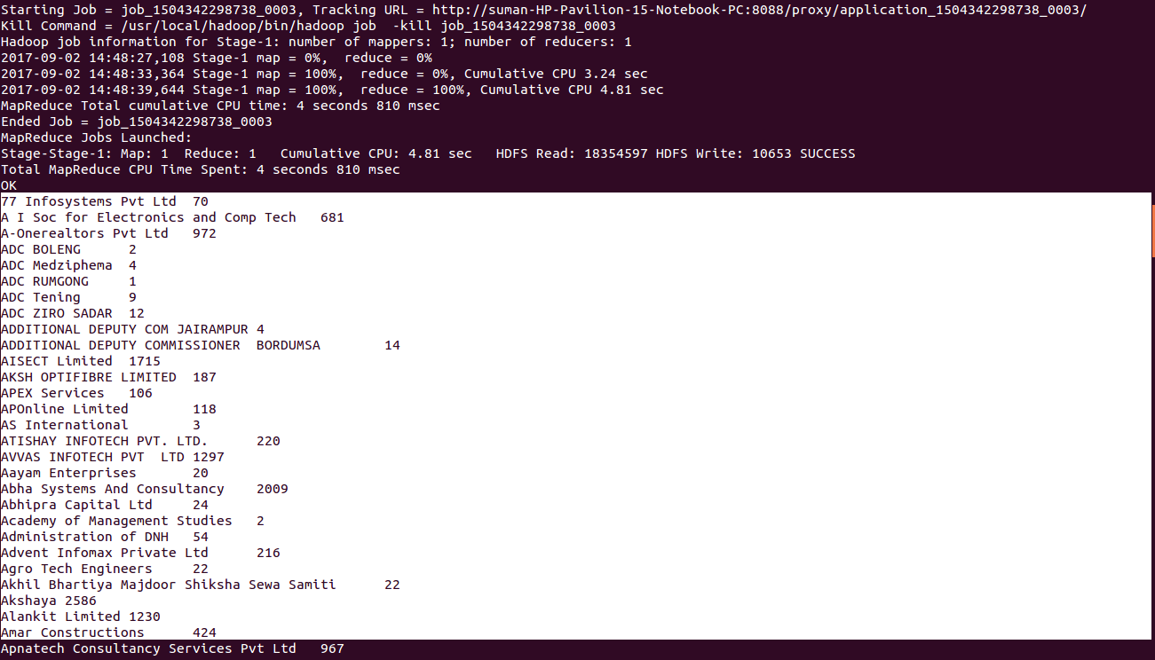

3. Find Top 10 districts with maximum identities generated for both Male and Female?

---select district,gender,count(aadhar generated) as a from aadhar where aadhar generated=1 and gender='M' group by district,gender order by a desc limit 10;
=======top 10 districts identities for Male=============
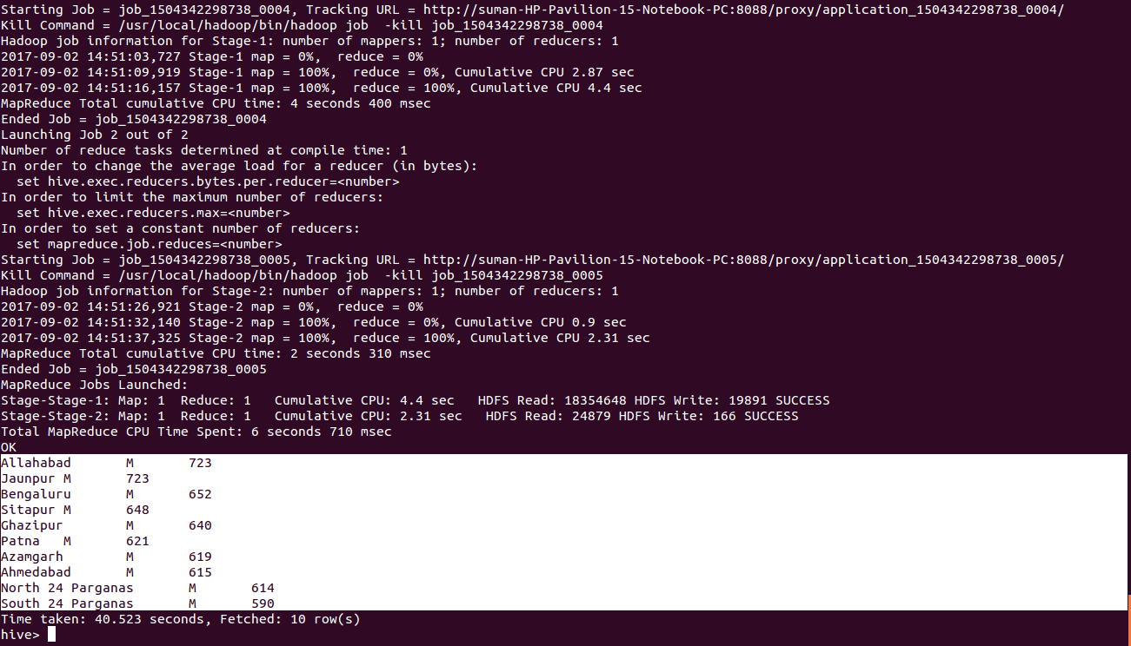
---select district,gender,count(aadhar generated) as a from aadhar where aadhar generated=1 and gender='F' group by district,gender order by a desc limit 10;
===========top 10 districts identities for female===========
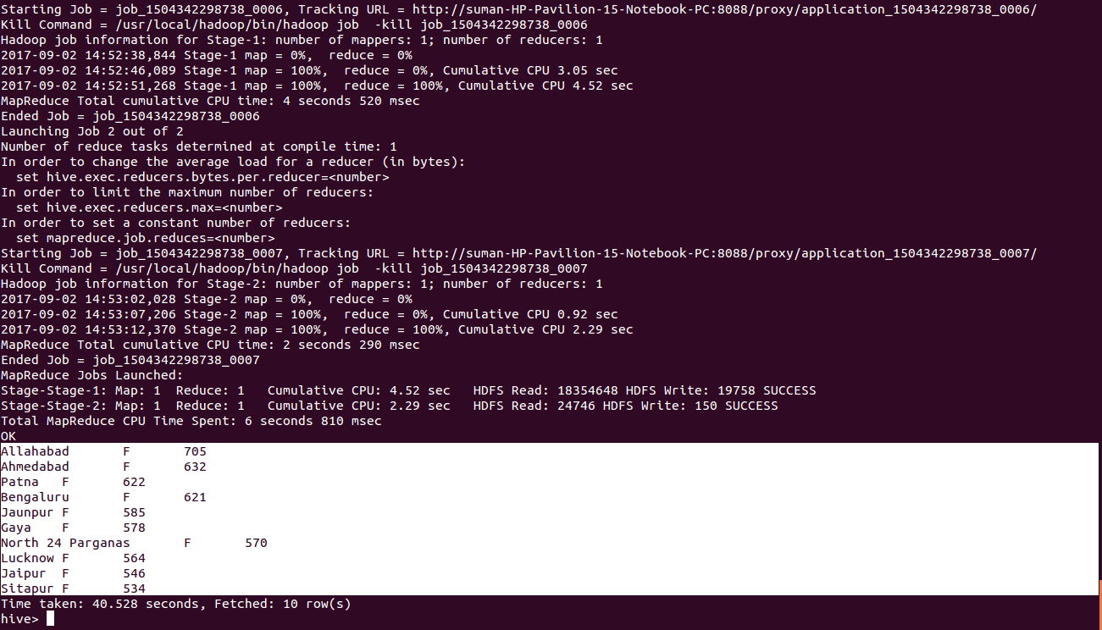

4. Find out the total number of cards rejected by states?
---select state,count(enrolment rejected) from aadhar where enrolment rejected=1 group by state;

This is the output for number of aadhar cards rejected by each states.

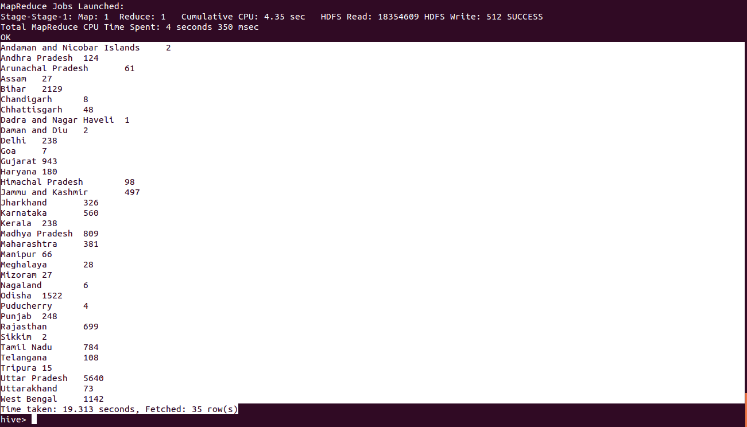

5. Find out the age groups with their respective number of identities?
---select age,count(aadhar generated) from aadhar where aadhar generated=1 group by age;

This output is the Count of the aadhar cards with respective to the age groups.
